soft play with

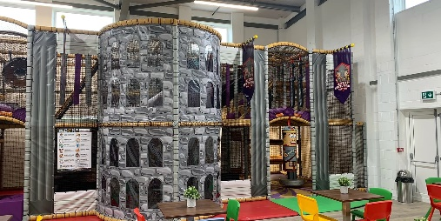 I will meet Allsorts families at the Soft Play



[This Photo](https://en.wikipedia.org/wiki/File:Green_tick.svg) by Unknown Author is licensed under [CC BY-SA](https://creativecommons.org/licenses/by-sa/3.0/)

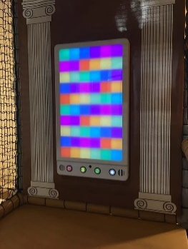 I can play in the sensory area



[This Photo](https://en.wikipedia.org/wiki/File:Green_tick.svg) by Unknown Author is licensed under [CC BY-SA](https://creativecommons.org/licenses/by-sa/3.0/)

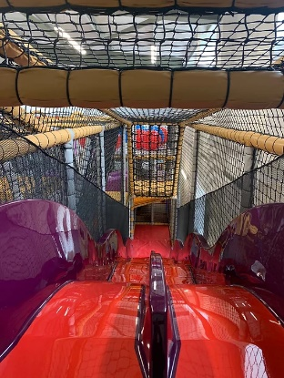 There is a slide



[This Photo](https://en.wikipedia.org/wiki/File:Green_tick.svg) by Unknown Author is licensed under [CC BY-SA](https://creativecommons.org/licenses/by-sa/3.0/)

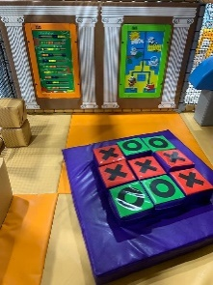 I will have lots of time to play



[This Photo](https://en.wikipedia.org/wiki/File:Green_tick.svg) by Unknown Author is licensed under [CC BY-SA](https://creativecommons.org/licenses/by-sa/3.0/)



[This Photo](https://en.wikipedia.org/wiki/File:Green_tick.svg) by Unknown Author is licensed under [CC BY-SA](https://creativecommons.org/licenses/by-sa/3.0/)

We can have a drink in the cafe

 When our family trip finishes, I will say goodbye to Allsorts



[This Photo](https://en.wikipedia.org/wiki/File:Green_tick.svg) by Unknown Author is licensed under [CC BY-SA](https://creativecommons.org/licenses/by-sa/3.0/)